S&SE Asia special issue
Significance special issue on South and South-East Asia

No Warning. No Escape.
Rethinking flood warnings after the Ditwah Cyclone and devastating floods in Sri Lanka
Priyanga Dilini Talagala
Department of Computational Mathematics, University of Moratuwa, Sri Lanka
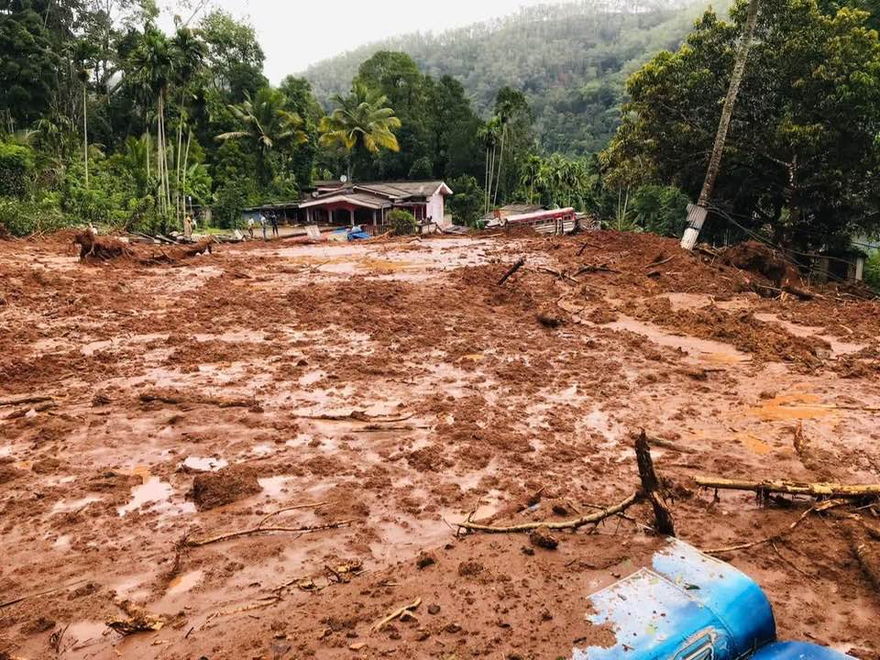
Email: priyangad@uom.lk
Figure 1: Landslide damage in Sri Lanka caused by Cyclone Ditwah, showing a fully destroyed house and a nearby public bus affected by the landslide (November 2025)

Unusual observations in data usually speak first. Disasters follow only if we ignore them. In most data modelling workflows, we start the modelling process with the preprocessig step, where unusual observations, also known as outliers or anomalies, are detected and often deleted or ignored to avoid biased estimates, misspecified models, misleading results, and poor decisions. Yet in some cases, these unusual observations can be the main carriers of vital information and identifying them, instead of deleting them, should be the central goal of the modeling process. Extreme weather conditions such as cyclones and floods are a clear example of this reality.
“Unusual observations in data speak first. Disasters follow only if we ignore them.”
Recently Sri Lanka experienced widespread floods and landslides across all the districts in the country with the landfall of Cyclone Ditwah in late November 2025. According to the World Bank Group's Global Rapid Post-Disaster Damage Estimation (GRADE) report on Cyclone Ditwah 2025, Sri Lanka, it’s the worst natural disaster Sri Lanka has faced in recent history since the 2004 tsunami. It resulted in the loss of over 650 innocent lives. In addition, more than 6000 houses were completely destroyed and over 100,000 partially damaged, causing economic losses exceeding 4 billion US dollars of damage across the country. This damage is about 4 percent of Sri Lanka’s GDP. Even though Cyclone Ditwah’s center was off Sri Lanka’s eastern coast, Colombo, the largest city of Sri Lanka by population, recorded the highest impact, with over 30,000 people affected, as persistent rainfall triggered Kelani River overflow and severe urban flooding that overwhelmed the city’s drainage system.
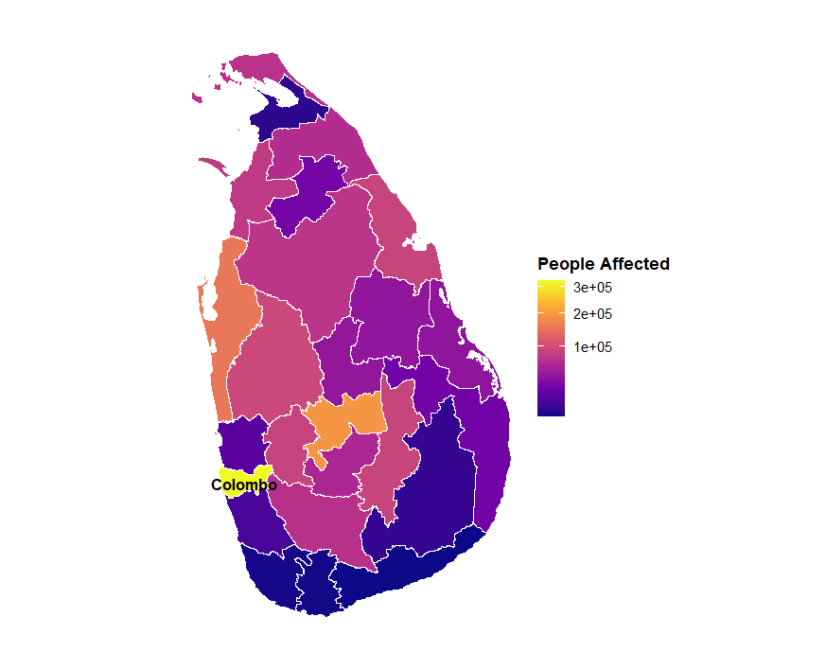
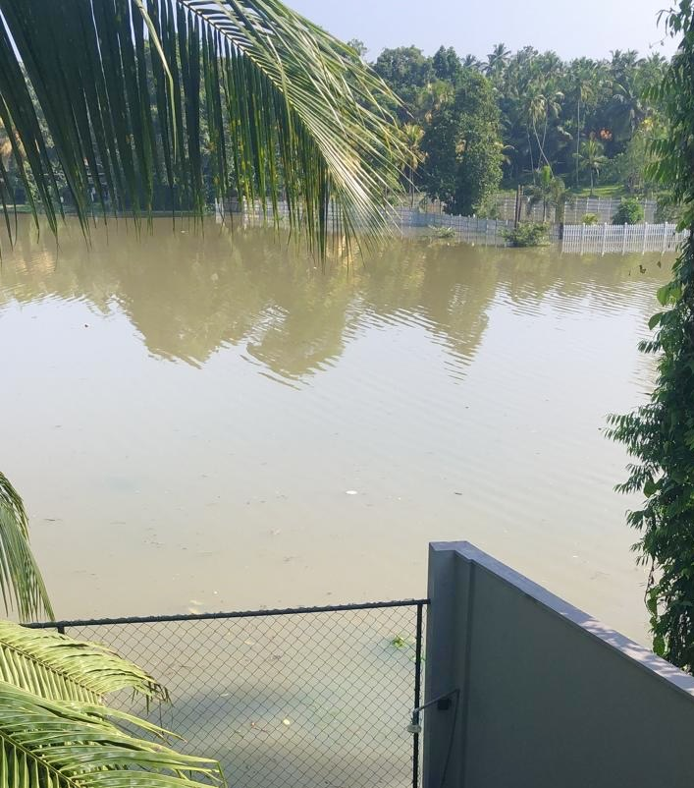

Figure 2: Left: A paddy field in Kelaniya, Colombo, within the Kelani River basin, was fully submerged by floodwater in November 2025 after heavy rainfall caused the Kelani River to overflow and flood surrounding low-lying areas. Right: Map showing the number of people affected by Cyclone Ditwah across Sri Lanka.
The Disaster Management Centre website of Sri Lanka’s Ministry of Defense, Sri Lanka (https://www.dmc.gov.lk/), has been providing irregular but frequent updates on river water levels of several gauging stations across multiple water basins all around the country, even well before the Ditwah Cyclone made landfall. It also contains flood warning thresholds for alerts as well as minor and major flood warnings. Despite this, the country experienced massive damage affecting lives, homes, infrastructure, and essential services. The question, then, is why the country was unable to avoid or at least minimize such massive losses even when relevant data were readily available throughout the event. The sections that follow take a closer look at this issue through a SWOT analysis of Sri Lanka’s early flood warning system, exploring its strengths, weaknesses, opportunities, and threats.
Acronyms
- AI- Artificial Intelligence
- GDP - Gross Domestic Product
- SWOT - Strengths, Weaknesses, Opportunities, and Threats
- CRAN- Comprehensive R Archive Network
- OWSD-UNESCO- The Organization for Women in Science for the Developing World- United Nations Educational, Scientific and Cultural Organization

Definitions
- Outliers/ Anomalies - Unusual observations in a given dataset.
- Data preprocessing - Cleaning, transforming, and organizing raw, messy data into a clean, structured format that's suitable for analysis and modelling
- Biased estimates- Calculated results of a statistical or predictive model systematically overestimates or underestimates a true value

Rising from the current system
Sri Lanka’s flood warning practices do not need to start from scratch, as they already have a solid foundation that can be strengthened and improved. For instance, the country maintains a rich database with frequent real-time measures of river level data accessible through the Disaster Management Centre website. This provides a solid foundation for a better, updated, data-driven early warning system. Further, there are several open-source software tools with anomaly detection capabilities. For example, the recently released CRAN task view on anomaly detection (https://cran.r-project.org/web/views/AnomalyDetection.html) has the potential of guiding new cost-effective tools and data-driven automated techniques for early flood warnings. In addition, Sri Lanka has the highest literacy in the South Asian region, around 92%. The digital literacy of the country is also of considerably high value. This enables people to understand the value of such data-driven early warning systems and respond to them accordingly. The media has a huge role to play in this regard in disseminating these warnings and raising public awareness. Beyond traditional media, social media platforms also have the capacity to disseminate timely warnings, particularly given the high level of social media use across the country, with roughly 9 million social media users as of October 2025, representing about 38% of the population (Kepios. (2026). Digital 2026: Sri Lanka. DataReportal. https://datareportal.com/reports/digital-2026-sri-lanka) .
Current system that misses the mark
“Data is the backbone of any data-driven decision-making process”
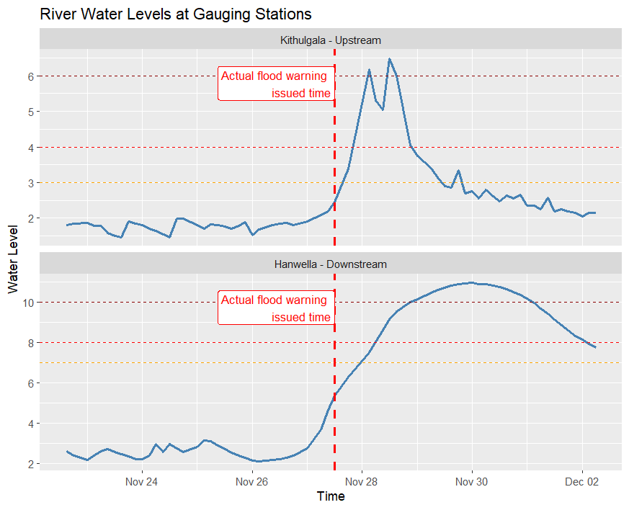
Sri Lanka does not need to start from scratch. Instead, it can strengthen the existing early flood warning system. Several practical improvements can be made to the existing flood warning systems and practices. Even though river level data are frequently collected and maintained via the Disaster Management Centre website, they are often available in unstructured formats that demand significant time and effort to convert into a form suitable for modeling. Data is the backbone of any data-driven decision-making process. There is a famous belief that 80% of a data scientist's time is spent on data cleaning. This challenge is evident in the existing databases, which require substantial effort to convert into structured datasets before they can be used for model development. Another key weakness of the current system is the reliance on outdated and fixed thresholds to detect flood conditions. As a result, Sri Lanka often experiences floods before the alerts arrive. Ideally, warnings should precede floods, not follow them. Findings from our previous case study, funded by OWSD-UNESCO, revealed that the data has significant potential to give early flood warnings ahead of actual flood incidents. But the problem is the fixed, outdated thresholds that are set too high, preventing the data from signaling risk until the disaster has already begun. For example, as shown in Figure 3, the observed water levels showed clear early warning signs through increasing trends when compared with historical patterns. However, the existing flood alert thresholds were set at considerably higher value. As a result, timely warnings were not issued even though the rising water levels indicated an impending flood disaster.

Figure 3: Water levels at two gauging stations in the Kelani River basin. Horizontal dashed lines indicate the exisiting flood alert, minor flood, and major flood thresholds, arranged from bottom to top in each plot. The actual flood warning issued time is marked by a vertical red dashed line.
In addition to that, these thresholds should be updated to reflect the changes in the typical behavior of the environment. In a statistical context this is known as nonstationarity in the data, and in a machine learning context this concept is known as concept drift. The typical behavior of a given system changes over time. Then our models should be updated according to the changing environment. After the economic crisis, the country experienced a significant boom in infrastructure development and construction. Climate change is another major concern that must be considered when designing an effective early flood warning system. The flood warning thresholds should be updated according to the changing environment using advantaged data driven analytical techniques. Only then can we come up with a more realistic and adaptive threshold to issue timely and effective warnings. Further, the lethargic attitude of practitioners and government agencies towards advanced statistical and AI modelling practices further limits the effectiveness of the current flood warning system.
“Warnings should precede floods, not follow them.”

Channeling the current system better
Detecting unusual observations in data is an emerging field with many different applications, including detecting events such as bushfires, earthquakes, tsunamis, air pollution, and floods, which often occur as significant deviations from typical environmental conditions. However, the unusual observation in data, commonly known as an anomaly in statistical literature, doesn’t have a unified definition, and the definition depends on the context and behavior of the data. On the other hand, anomaly detection methods are heavily influenced by the way we define an anomaly. This is where the real challenge comes, as identifying the most suitable approach from a large pool of candidate models for detecting anomalies requires proper investigation of data. Data visualization plays a critical role in this regard. Another important aspect we can consider in a river network is the relationship between upstream and downstream stations. This relationship can be used to predict downstream behavior using upstream data. If the lead-lag relationship between gauging stations is properly identified, we can better predict unusual changes such as sudden increases in river water levels of downstream using upstream data. This can help in forecasting potential flood conditions in certain parts of the country and support early warning systems to reduce future disaster impacts.
Points of Caution
Even though advanced analytical techniques for detecting unusual observations in data have the potential to give early flood warnings, they still have some threats that can hinder their success. Lack of interpretability of advanced models along with technical language can reduce public interest and trust of early warning systems. Further, due to rapid changes in environmental conditions, the existing models can easily become outdated if they are not regularly updated with the changing environmental conditions. Repeated flood warning alerts that do not result in visible flooding can cause the public to ignore future warnings, while missed or late warnings during extreme weather conditions can lead the public to undermine confidence in further flood warning alerts. Moreover, cyberattacks targeting national flood warning systems could cause severe threats to national security and public safety. Public awareness and effective data communication are vital to overcoming these challenges
Key takeaway
The key takeaway from this article is that the anomalies, or unusual observations, in data should not be blindly deleted or ignored, as they often carry vital information, and proper identification of these anomalies using data driven anomalous thresholds is essential for minimizing future losses.
Acknowledgement
This article is based on the research work carried out through the RETINA research and innovation project. This work was carried out with the aid of a grant from UNESCO and the International Development Research Centre, Ottawa, Canada. The views expressed herein do not necessarily represent those of UNESCO, IDRC, or its Board of Governors.
Author Bio: Priyanga Dilini Talagala is a senior lecturer in the Department of Computational Mathematics, Faculty of Information Technology, University of Moratuwa, Sri Lanka. She earned her PhD in statistics and mathematics from Monash University, Australia. She is the main maintainer of the CRAN task view for anomaly detection, which provides a comprehensive list of open-source R packages for anomaly detection.
Personal website: https://prital.netlify.app/

